Frist stage: Story telling

* Traditional waste recycle game used to be separate and simple.
* The main audience are children.

Assemble 4 games with a game line.

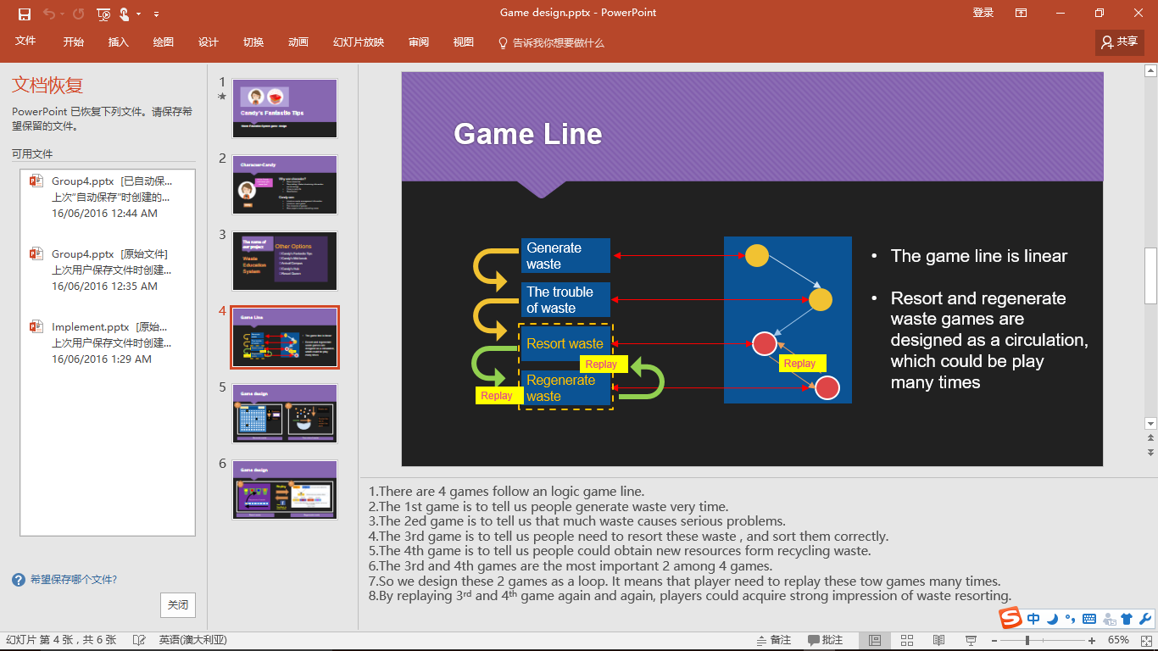

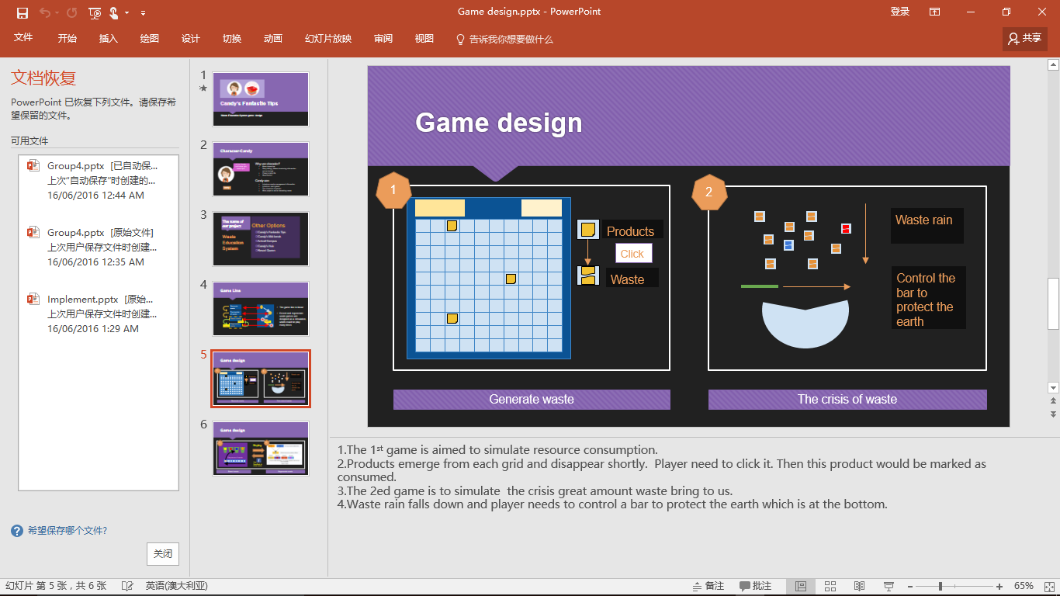

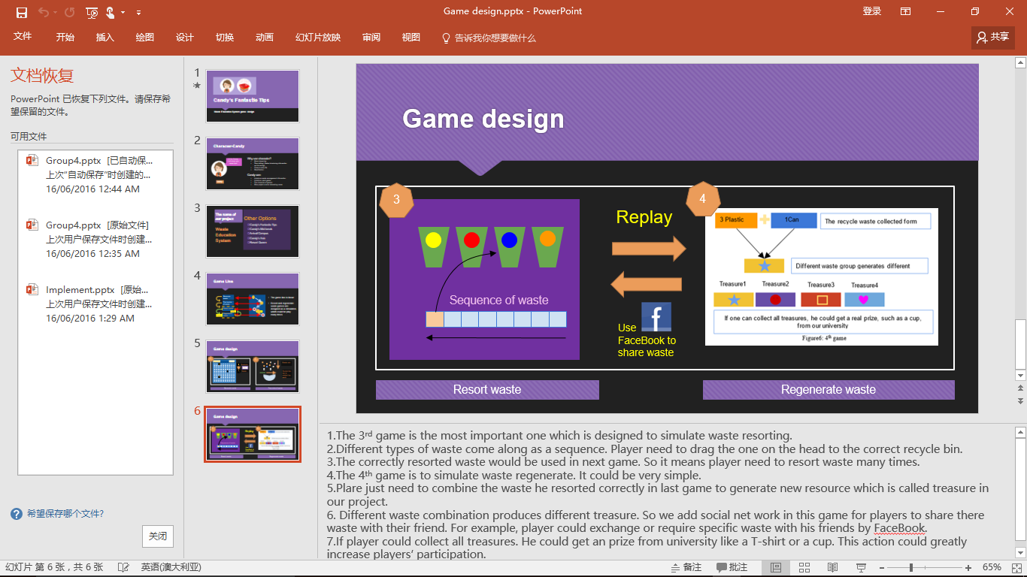

A very similar one - [Port Adelaide Enfield - Stuff for Kids](http://www.portenf.sa.gov.au/page.aspx?u=1040)

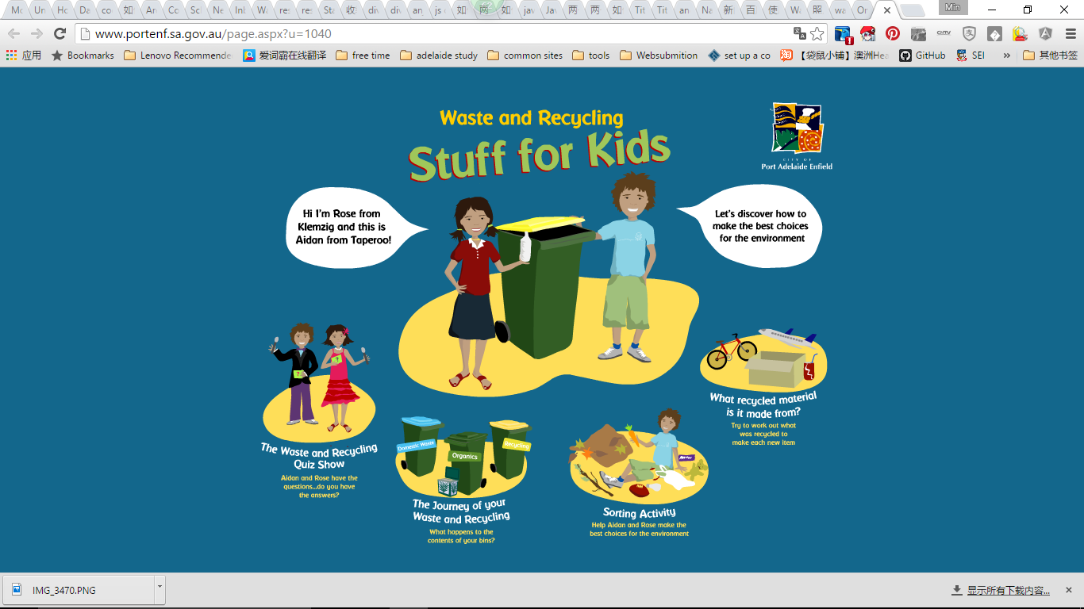

<http://www.portenf.sa.gov.au/page.aspx?u=1040>

Second stage: Specific

Application definition：It is a gamifying waste recycling education application, especially for the student of University of Adelaide.

**General thinking about the game design:**

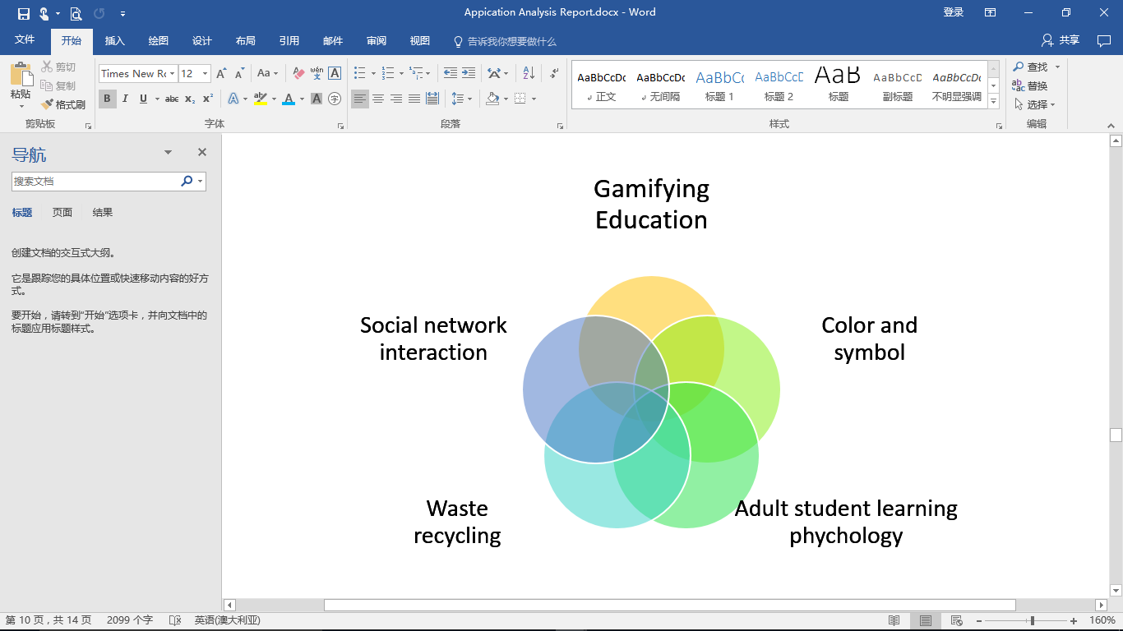

Colour and Symbol:

|  |  |  |
| --- | --- | --- |
| Recycling = Yellow | Waste (landfill) = Red | Food Scraps = Green |

**Specific thinking about the game design.**

The 2 of the most serious recycle problems in Hub

1. **Coffee cup recycle**

*The analysis found that coffee cups are a major component of the waste stream, and analysis of the audit data indicates approximately:*

***300*** *coffee cups are disposed of at the Hub each day (****57%*** *into the* ***general waste bins*** *and*

***43%*** *into the* ***recycling bins****); and*

***73,000*** *coffee cups are disposed of at the Hub each year.*

1. **Container recycle (**empty/with food/ with liquid**)**

|  |  |  |
| --- | --- | --- |
| Recycling = Yellow | Waste (landfill) = Red | Food Scraps = Green |
| Empty Coffee Cups | Chip packets | Apple cores |
| Magazines/leaflets | Lolly wrappers | Mandarin peel |
| Newspaper | Soft plastic wrap | Sandwich |
| Cans | Plastic bags | Hotdog |
| Empty Glass Bottles | Take away containers with food | Tea bags |
| Cartons | Coffee cups with liquid | Paper towel |
| Empty Plastic Bottles | Bottles/cans with liquid | Tissues |

* Colour and symbol is the most important consideration in game design.
* More complicated game content.
* 2 specific games. The one for coffee cup recycle, the other for containerrecycle

The third stage: Smart Green Mind(SGM)

* Although the application definition is quite clear, we cannot ensure the learning effect and adherence of students.
* We try to add some social functions and tools into application. However, the effect will be very hard to measure, while the development complexity and cost will increase sharply.
* Even though game might be very interesting, learning is still not attractive.

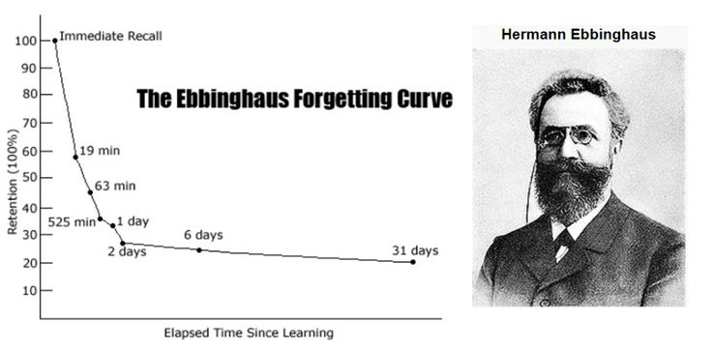

**Colour + symbol+ sorting 🡪 Brain Training**

* Brain training game is very suitable for learning.
* Brain training game is very popular among adult.
* Brain training game is quite simple and attractive.

**Brain Training +** **Gamifying Waste Education = Smart Green Mind**

* Smart not only means lift the capacity of one’s mind, but also means lift one’s awareness of waste classification.